Mini Hardware Problem: Audio Pass-through

First, need to know what computer outputs through 3.5mm headphone jack. Using an online tone generator website and connecting a 3.5mm jack to my laptop with the two audio ends stripped down to copper:

<https://onlinetonegenerator.com/frequency-sweep-generator.html>

Generating a sweep from 1Hz to 25,000 over 10 seconds at 100% volume

|  |  |
| --- | --- |
| https://media.discordapp.net/attachments/765008126394105878/767464793279561728/unknown.png?width=343&height=593 |  |

My laptop output is ~1.8Vpp with ~+-0.9V at most frequencies (dips down in lower frequencies). This is with “Windows Sonic for Headphones” turned off in my Windows sound settings.

I googled “bipolar audio signal to unipolar adc” and found a Stack Exchange post asking how to convert +-3.5V to 0🡪5V:

https://electronics.stackexchange.com/questions/413058/bipolar-to-unipolar-voltage-converter

A guy answered the question with this solution:

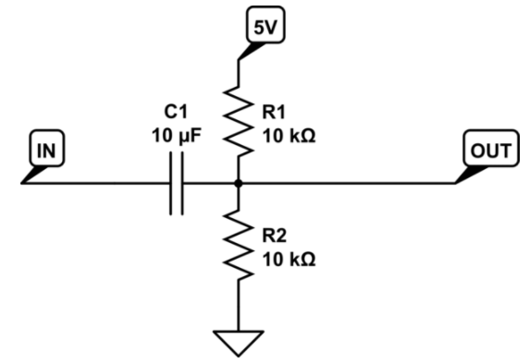

Using the Kinetis K22F 512KB Flash Technical Data Sheet I found the ADC electrical specifications

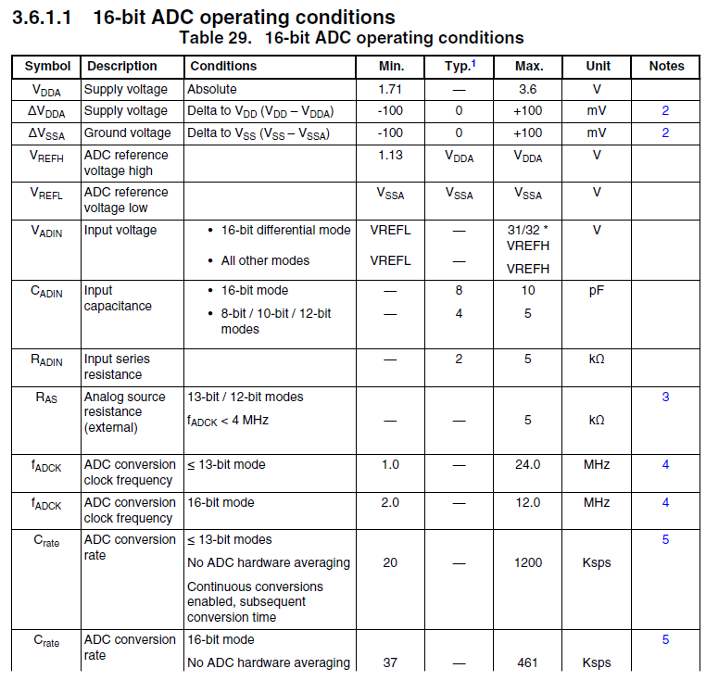



Used “Tina-TI” software to simulate circuit with the input voltage being 20Hz 1Vpp Sine wave, 20,000Hz 1Vpp Sine wave, and example .wav file of jazz music included in Tina-TI software:

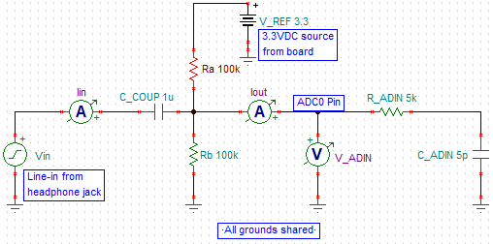

20Hz Sine wave with 1.8Vpp (max = 0.9V)

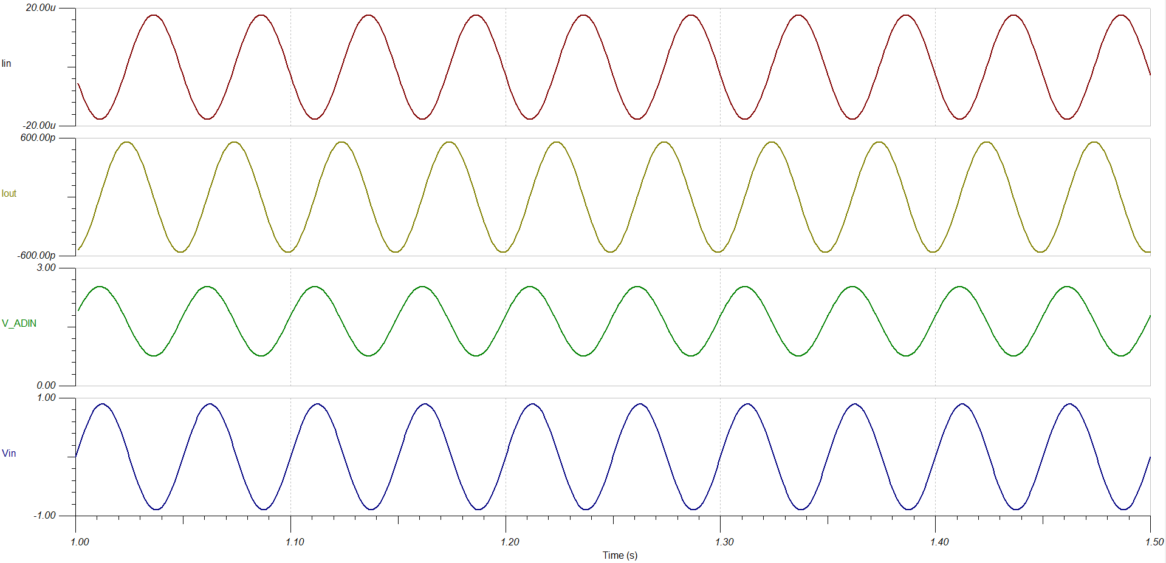

20,000Hz Sine wave with 1.8Vpp (max = 0.9V)

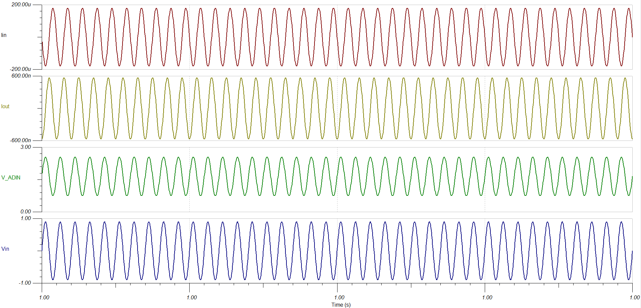

Example .wav file included with Tina-TI software of someone rapping with 1.8Vpp (max of 0.9V)

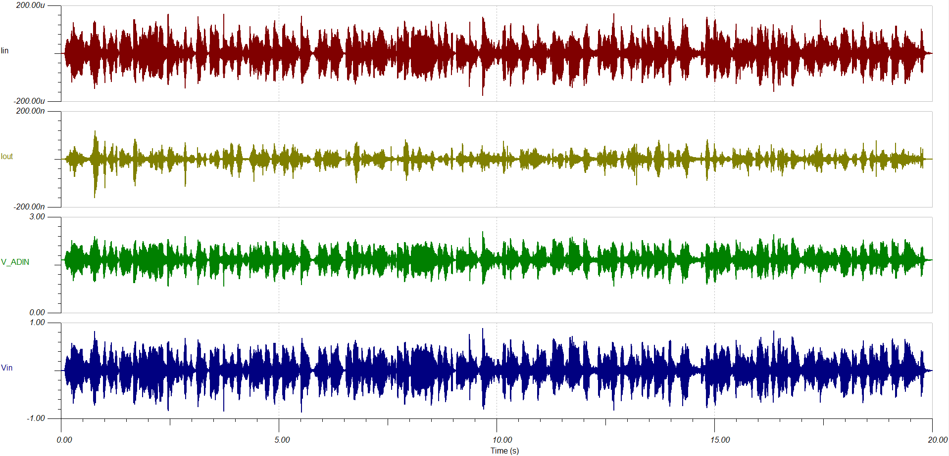

From these simulations we can see that at lower frequencies, the output amplitude is slightly (~-100mdB) smaller in amplitude, but we have an offset of 1.65VDC which is what matters.. We can see this dip in output amplitude by doing an AC sweep from 20Hz🡪20kHz

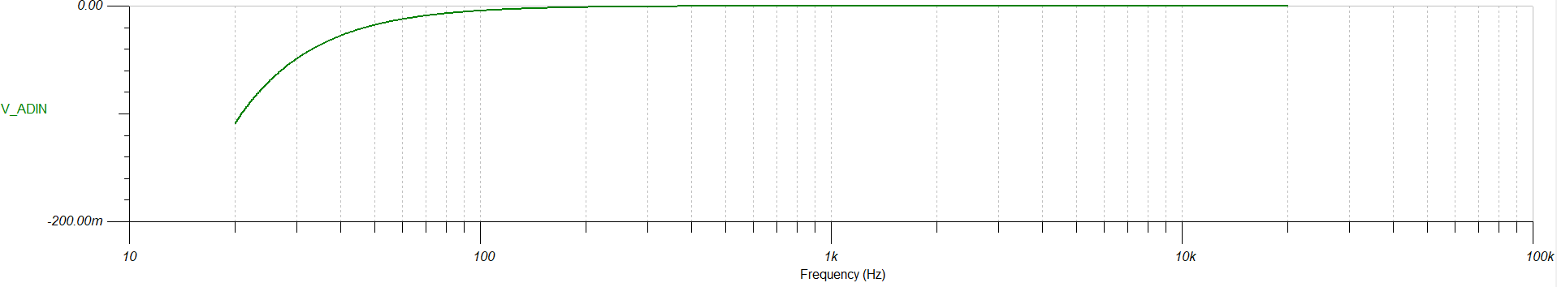

Build in lab and use waveform generator in place of laptop for input.

For all scope shots below 1 (Yellow) is audio input, 2 (Green) is output to ADC0

|  |  |
| --- | --- |
|  |  |
|  |  |

This looks like it is working correctly. Software for this is super easy:

